Assignment 4: N-Queens Problem

CODE:
<!DOCTYPE html>
<html>
<head>
<title>N-Queens Problem</title>
<style>
body {
font-family: Arial, sans-serif;
text-align: center;
padding: 20px;
background: #f5f5f5;
}
.controls {
margin: 20px;
}
input {
padding: 8px;
font-size: 16px;
width: 60px;
}
button {
padding: 10px 20px;
font-size: 16px;
margin: 5px;
cursor: pointer;
background: #2196F3;
color: white;
border: none;
border-radius: 5px;
}
button:hover {
background: #0b7dda;
}
.board {
display: inline-grid;
gap: 2px;
background: #333;
padding: 10px;
border-radius: 5px;
margin: 20px;
}
.cell {
width: 50px;
height: 50px;
display: flex;
align-items: center;
justify-content: center;
font-size: 30px;
}
.white { background: #f0d9b5; }
.black { background: #b58863; }
.info {
margin: 20px;
font-size: 18px;
font-weight: bold;
}
</style>
</head>
<body>
<h1>N-Queens Problem</h1>

<div class="controls">
<label>Board Size (N): </label>
<input type="number" id="nValue" value="4" min="4" max="8">
<button onclick="solve()">Solve</button>
<button onclick="nextSolution()">Next Solution</button>
</div>

<div class="info" id="info">Enter N and click Solve</div>
<div id="board"></div>

<script>
let solutions = [];
let currentSolution = 0;
let N = 4;

function isSafe(board, row, col) {
// Check column
for (let i = 0; i < row; i++) {
if (board[i][col] === 1) return false;
}

// Check upper left diagonal
for (let i = row, j = col; i >= 0 && j >= 0; i--, j--) {
if (board[i][j] === 1) return false;
}

// Check upper right diagonal
for (let i = row, j = col; i >= 0 && j < N; i--, j++) {
if (board[i][j] === 1) return false;
}

return true;
}

function solveNQueens(board, row) {
if (row === N) {
// Found a solution, save it
solutions.push(board.map(r => [...r]));
return;
}

for (let col = 0; col < N; col++) {
if (isSafe(board, row, col)) {
board[row][col] = 1;
solveNQueens(board, row + 1);
board[row][col] = 0; // Backtrack
}
}
}

function solve() {
N = parseInt(document.getElementById('nValue').value);
solutions = [];
currentSolution = 0;

console.clear();
console.log(`=== Solving ${N}-Queens Problem ===\n`);

let board = Array(N).fill(0).map(() => Array(N).fill(0));
solveNQueens(board, 0);

console.log(`Total Solutions Found: ${solutions.length}\n`);

solutions.forEach((sol, index) => {
console.log(`Solution ${index + 1}:`);
sol.forEach(row => {
let rowStr = row.map(cell => cell === 1 ? 'Q' : '.').join(' ');
console.log(rowStr);
});
console.log('');
});

if (solutions.length > 0) {
displayBoard(solutions[0]);
document.getElementById('info').textContent =
`Solution 1 of ${solutions.length}`;
} else {
document.getElementById('info').textContent = 'No solution found!';
}
}

function nextSolution() {
if (solutions.length === 0) {
alert('Please solve first!');
return;
}

currentSolution = (currentSolution + 1) % solutions.length;
displayBoard(solutions[currentSolution]);
document.getElementById('info').textContent =
`Solution ${currentSolution + 1} of ${solutions.length}`;
}

function displayBoard(board) {
const boardDiv = document.getElementById('board');
boardDiv.innerHTML = '';
boardDiv.style.gridTemplateColumns = `repeat(${N}, 50px)`;
boardDiv.className = 'board';

for (let i = 0; i < N; i++) {
for (let j = 0; j < N; j++) {
const cell = document.createElement('div');
cell.className = 'cell ' + ((i + j) % 2 === 0 ? 'white' : 'black');
if (board[i][j] === 1) {
cell.textContent = '♛';
}
boardDiv.appendChild(cell);
}
}
}

// Initial display
solve();
</script>
</body>
</html>

OUTPUT:

=== Solving 4-Queens Problem ===

Total Solutions Found: 2

Solution 1:
. Q . .
. . . Q
Q . . .
. . Q .

Solution 2:
. . Q .
Q . . .
. . . Q
. Q . .
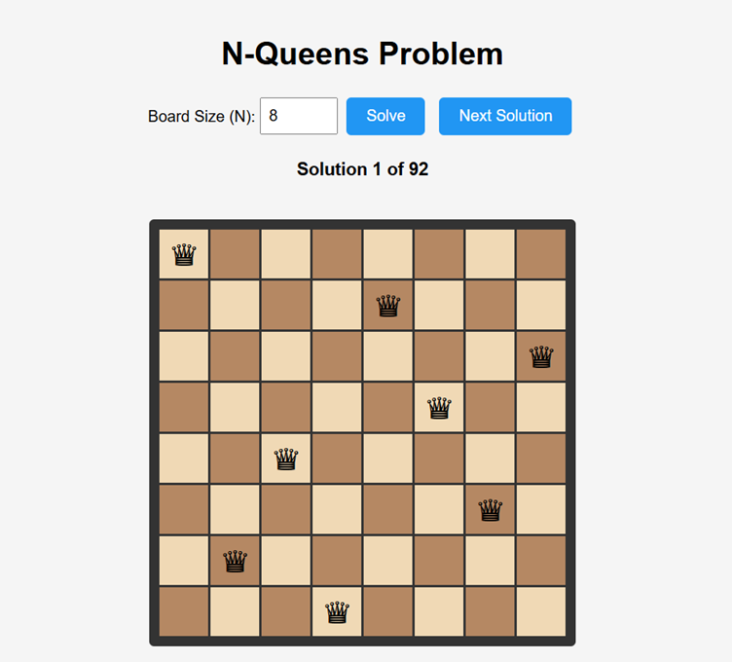

EXPLAINATION:
N-Queens Problem: Place N queens on N×N chessboard so no queen attacks another
Backtracking Approach:
- Start from row 0
- For each column in current row:
  - Check if placing queen is safe
  - If safe → place queen, move to next row
  - If we reach last row → solution found
  - Backtrack and try next position
- Repeat until all possibilities checked
isSafe() checks:
- Same column (vertical)
- Upper left diagonal
- Upper right diagonal
- (No need to check row or lower diagonals as we place row by row)
Time Complexity: O(N!)

